Learning-Based On-Track System Identification for Scaled autonomous racing under minute

(Reproducing and conclusion)

introduction
This paper uses a simple steps for identifying the tire pacjika model parameters
To identifying those parameter the following steps is being followed:
- Collect a dataset online while the car is moving using a model free controller such as pure-pursuit, the dataset collected contain the following .
- The data collection procedure last for 30 second, after that the data is then passed to the neural network to predict the error of the current reading and next reading from the dataset.
  - Neural network parameters [4 input layer , 8 neurons in hidden layer, 2 output layer].
  - The activation function for the hidden layer is leaky relu to introduce non-linearity.
- After the training finished a synthetic data is generated in the steady state with following condition:
  - is constant , and the steering is increasing linearly. The output is corrected from perviously modeled error network.
  - The steady state required to make the below equation valid
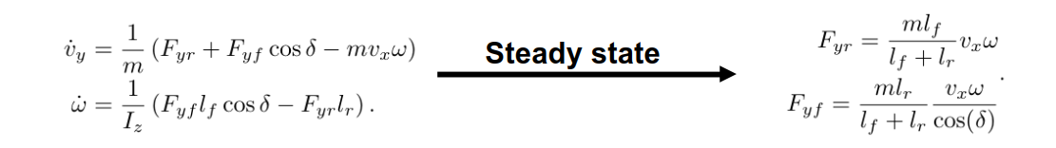
  - after the steady state data is generated; the pacjika tire is then estimated using linear least square regression.

Experiment design
The experiment used the f1tenth low fidelity simulator as stated int the following figure that
use simple mathematical models to simulate the car behaviors, and used RVIZ (ROS Visualization) as visualization tool.
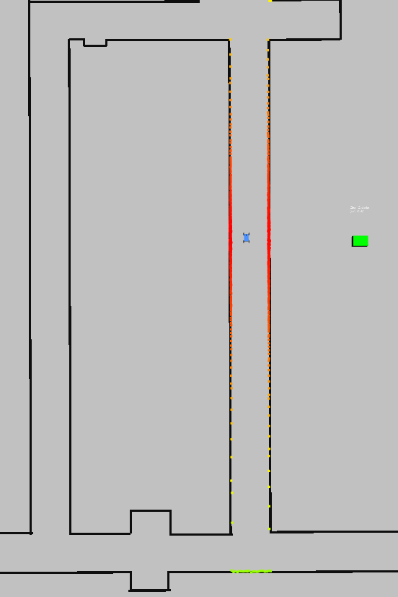Figure 1: simulator used
The provided parameter for the simulator is the mass, inertia, and the
vehicle dimension.

Multiple given path scenarios is give to test the approach in two main scenarios , to test if the approach need to excite the v_{y} and to give good result or not:
- Zigzag path
- Smooth straight path
Not only the path is change, but also the neural network’s parameters , linear velocity is changed to test the performance, and if the approach is pruned to over-fit quickly.
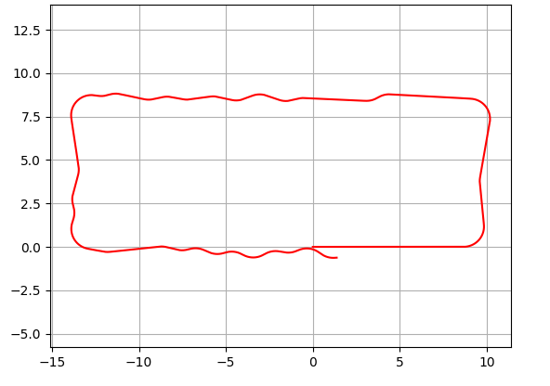Figure 2: Zigzag path
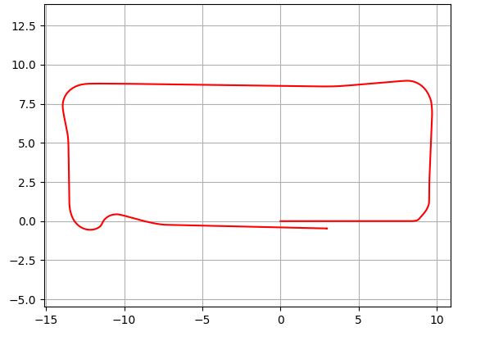Figure 3: smooth path

Test Cases under default parameters
Parameter Name | Value
data_collection_duration | 30 sec
num_of_iterations | 6
Num_of_epochs | 100
Learning_rate | 0.0005
weight_decay | 0.0
Linear velocity | 3.0 m/sec

Zigzag Path
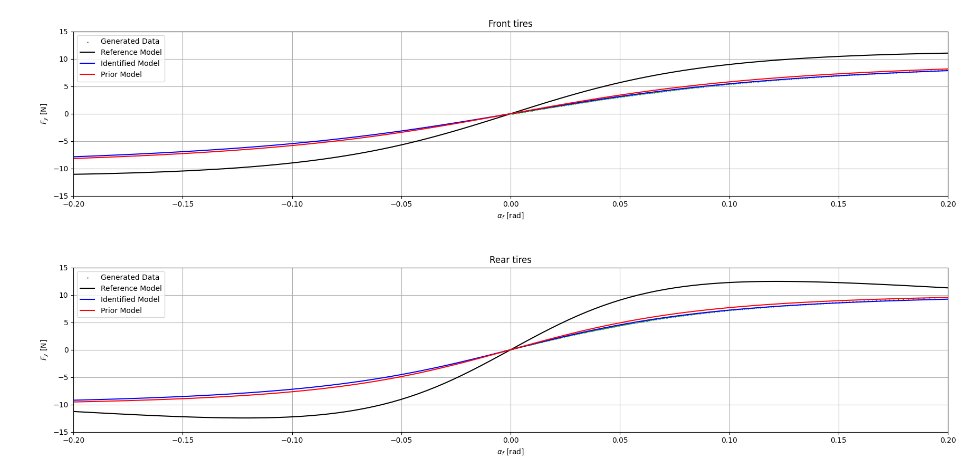
Figure 4: benchmarking of predicted tire forces and ground truth on zigzag path
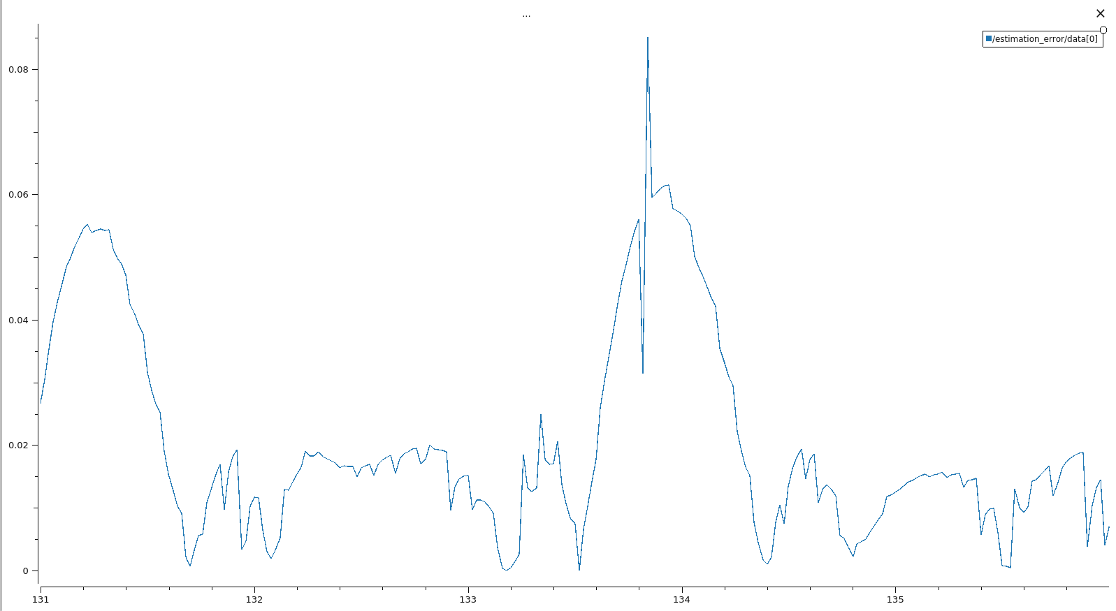Figure 5: estimated error between estimated vy and vy obtained from sensor
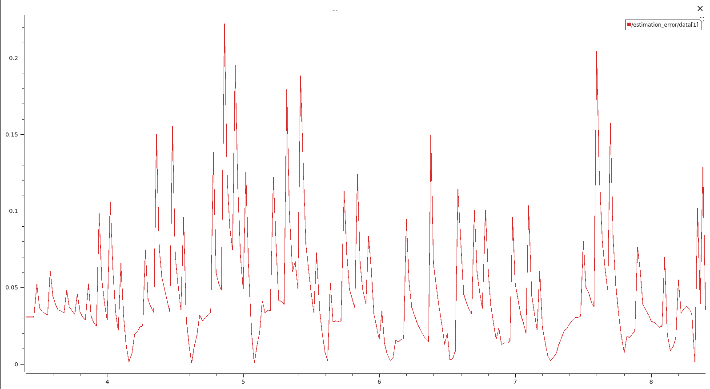Figure 6: estimated error between estimated w_z and w_z obtained from sensor

Smooth Path
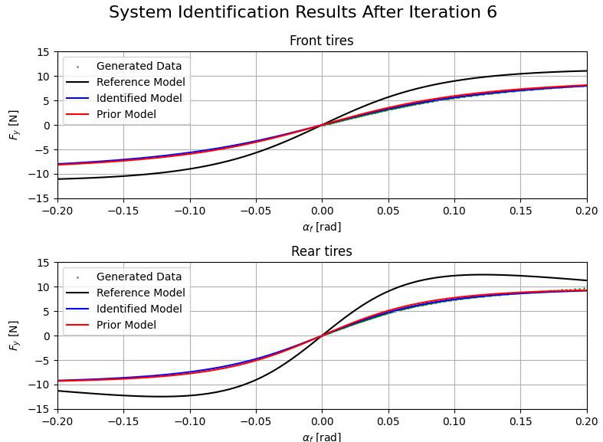Figure 7: benchmarking of predicted tire forces and ground truth on smooth path

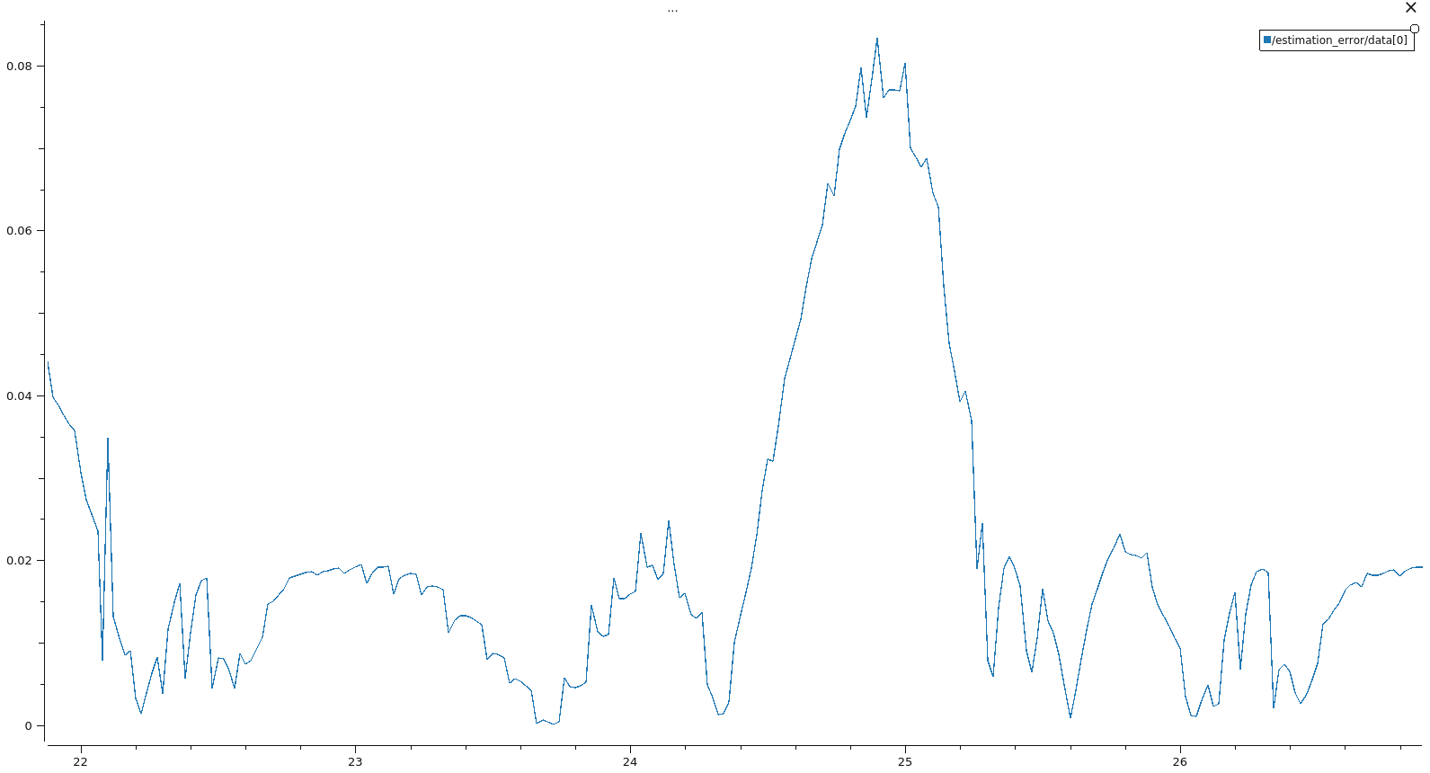Figure 8: estimated error between estimated vy and vy obtained from sensor in smooth path
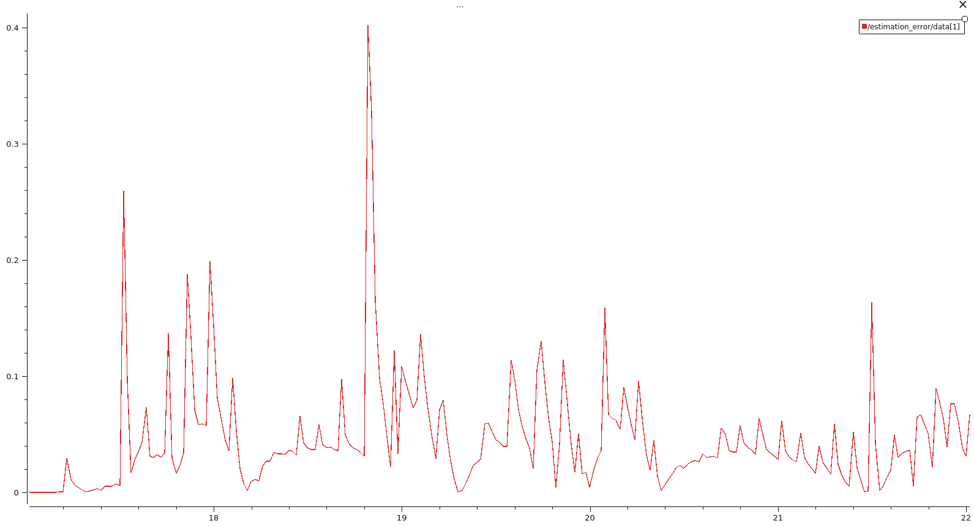Figure 9: estimated error between estimated wz and wz obtained from sensor in smooth path

Initial Conclusion
- The approach depend on one step prediction when benchmarking which is not a reliable option to test the algorithm
- The approach is very prune to over fit on the generated data on steady state method
- The error increase at sharp corners that can lead to slippage in the car if we use
- Dependencies on low fidelity simulator such as f1 10th simulator that use simple mathematical solver
- The system prune to low speed driving (the speed must be above 2.5 m/sec) and collision in identification phase.

Suggested next steps
- Test the same approach on IPG
- Implement MPC with identified parameter to see the how the approach affect the car behavior
- Add LSTM as suggested by the author to the architecture and see the results
- Change the regression type in the phase of identification of the pacjika tire model

